High speed counting and filling
- Counting speed of up to 5000 grains/min
- Compact design
- Compatible with filling station Contafill 2
- Fully controllable via PC software
- Removable Hoppers
- Robust and reliable in operation
- Counting of small seeds and cereals
- Five parallel counting channels

Increase the efficiency of Counting

Contador 2
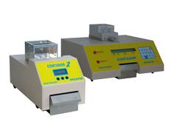

Application
The Contador 2 is a newly developed instrument which is based on the practical experience with the renowned seed counter Contador.
The proven handling of the hoppers, the short feeding distance and the high counting precision are now complemented by a considerably higher counting speed. With the traditional Contador it took approximately 90 seconds to count 1000 rapeseeds, with the Contador 2 this only takes 12 seconds.
Hopper for small seeds (no. 1) or cereals (no. 2) allow fast and flexible use for different seed types.
This concept permits a fast change of samples without having to empty the counting channels.

Operation
The hopper is placed onto the Contador 2 and the sample is filled in. The instrument automatically recognizes the container and loads the optimal parameters. After defining the counting quantity, a magnet holds the feed container and a vibrating element causes it to oscillate.
A specially developed algorithm ensures an optimal feed rate to guarantee a high counting speed and precision.
Counting parameters and feed rate can also be set individually and saved in an individual configuration.
The container is designed for a volume of 250 cm³. This corresponds for example to approx. 35,000 rapeseeds. The version for wheat (270 cm³) has a capacity of approx. 4,500 grains.

