
INSTALLATION AND INSTRUCTION MANUAL FOR HOFFMAN BATCH TYPE DEBEARDER
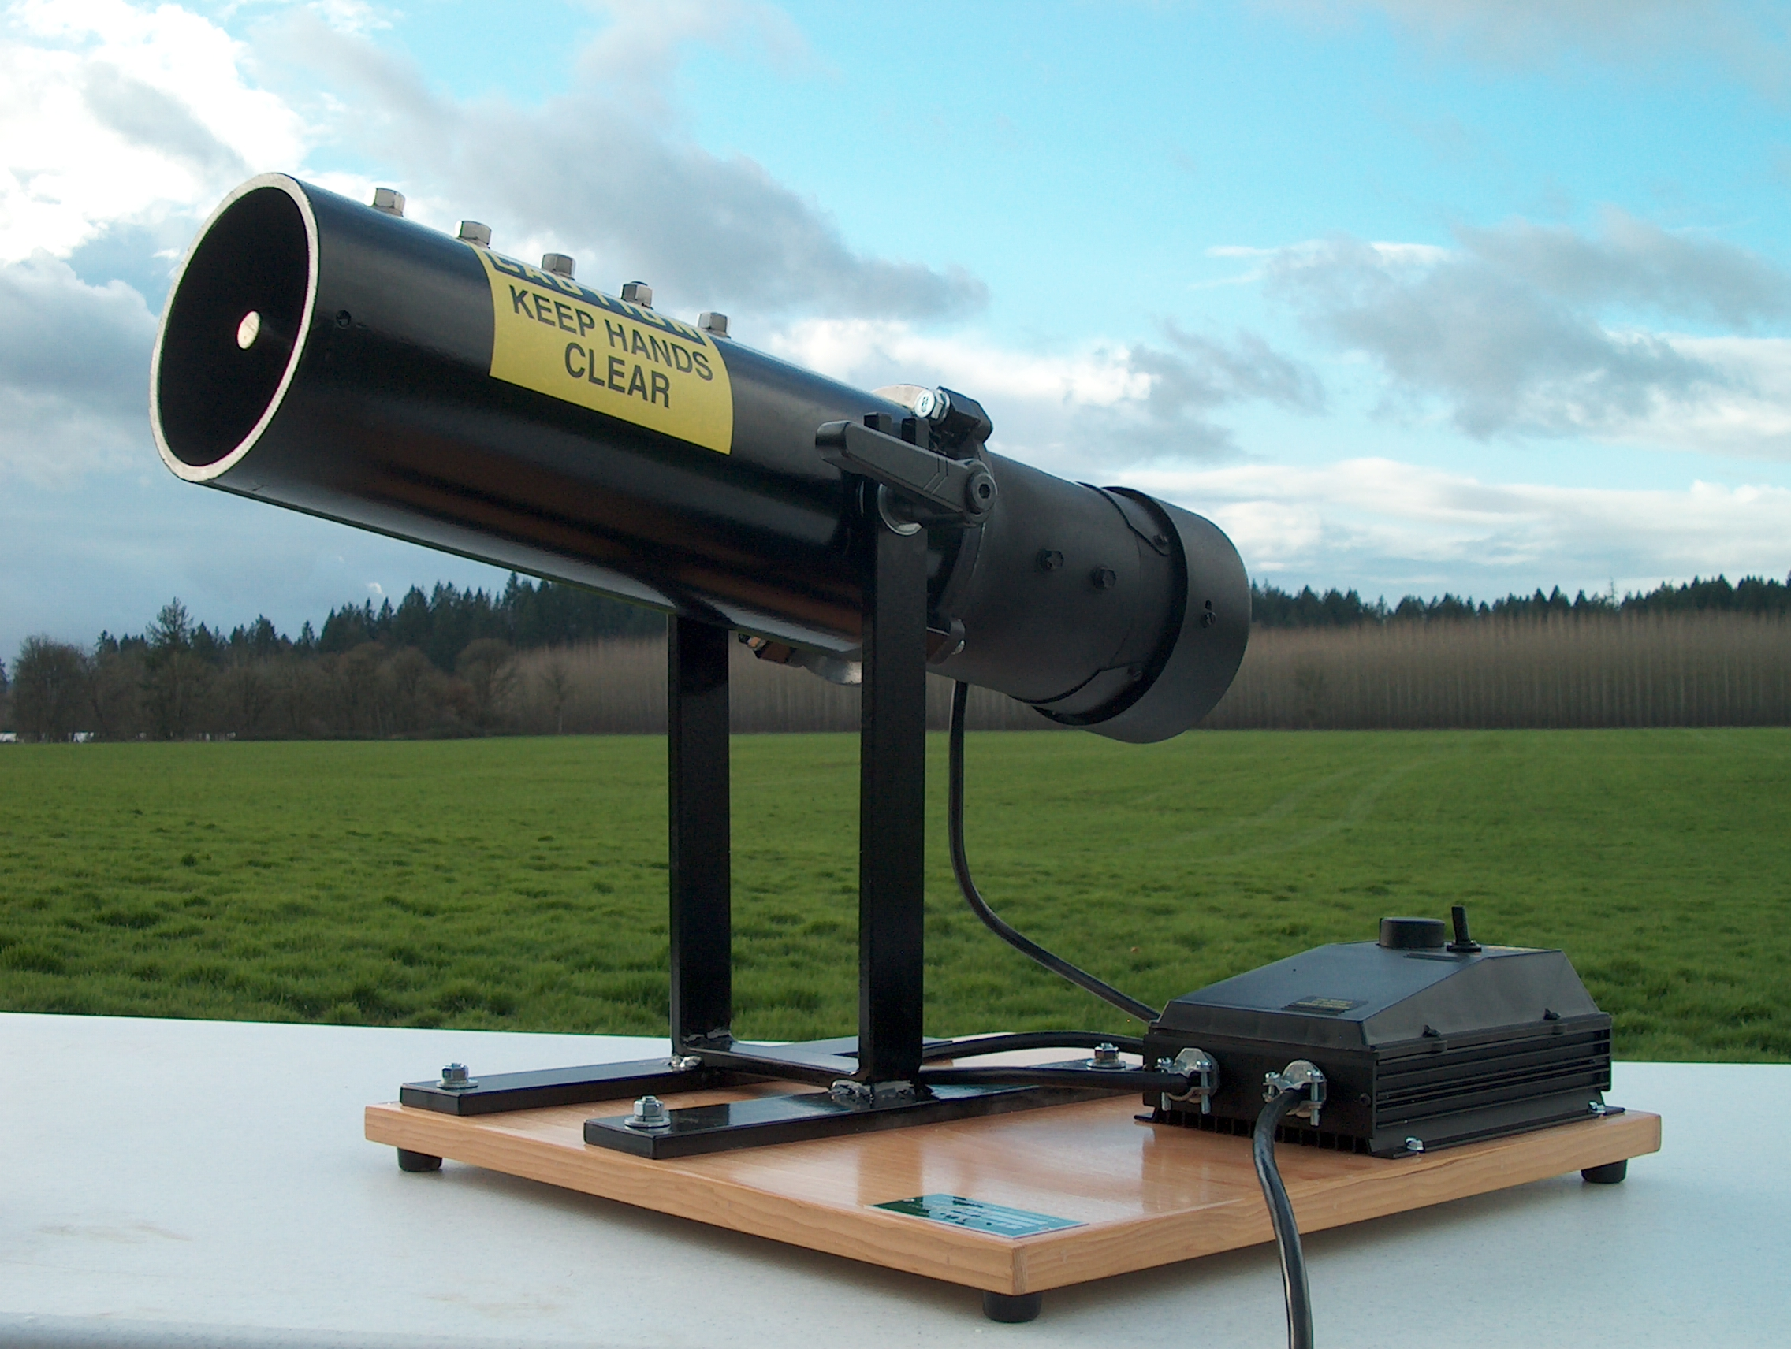

RECEIVING YOUR NEW DEBEARDER
Congratulations on your recent purchase of a Hoffman Batch Type Debearder. Please thoroughly examine the shipping crate for any punctures, dents or signs of rough handling. It is in your best interest to partially remove or open the shipping container in order to examine the unit for concealed damages that may have occurred during shipment. If the unit is damaged, it must be noted on the delivering carrier’s delivery slip or bill of lading.

GENERAL INFORMATION AND IMPORTANT OPERATING FACTS
This manual has been compiled to aid in the installation, operation and maintenance of your new equipment. Please take the time to read all of the material in order to become more familiar with your equipment and its operation and to enjoy optimum performance.

UNPACKING YOUR NEW UNIT
The shipping container should remain on your unit as protection against dents or scratches while transporting it to the actual set-up location. Remove the shipping container only at the last possible moment by following these simple steps:
1. Using a Phillips screwdriver remove the screws on the top of the crate.
2. Lift off the top and carefully remove the sides.
- Remove any packaging material and straps holding the unit down.
- Carefully lift the unit out of the container bottom.
DO NOT LAY YOUR NEW UNIT ON ITS SIDES OR TOP.

INSTALLATION AND LOCATION
The final location site of your new unit must be on a flat level surface.

ELECTRICAL CONNECTIONS
To insure proper operation, your new unit must be connected to an individual circuit that can supply the full voltage as stated on the serial data plate. For correct voltage, power draw, and wire accommodations, check the data on the serial data plate located on the unit. Verify that this information exactly matches the electrical characteristics at the installation location. All 208-230V models are provided with four (4) field wiring leads which must be permanently connected to the appropriate electrical plug. This wiring should be connected to the appropriate power source by a qualified electrician and must conform to all local electrical codes.

OPERATION

For safety, remove the electrical plug from the power source before proceeding.

Remove the end cap by loosening the two setscrews on either side of the end cap. The black handle locks and unlocks the unit for pitch adjustment. Turning the handle counterclockwise loosens the unit for pitch adjustment and alternately turning the handle clockwise tightens to hold the pitch of the unit in place.

Trials may be needed to set the pitch for the ideal debearding of material. The pitch of the unit can determine the amount of threshing. The pitch adjusts how fast gravity feeds the material to the removal point. The greater the pitch, the less threshing will be achieved before the product reaches the end cap for removal. The lesser the pitch, the longer the material spends in the debearder before reaching the removal point.
To begin pitch the unit back and load the debearder cylinder with material. Replace the end cap and set the unit to the desired pitch and tighten the black handle. Plug the unit in and flip the switch located on the side to turn the unit on and off.

After the material is debearded to your satisfaction, remove the end cap. The unit can be pitched forward to help collect the product.
CLEANING YOUR UNIT

With the power switch in the off position, remove electrical plug from power source. Loosen the setscrews located on either side of the clear acrylic end cap. With the end cap removed you may use low pressure air to blow out the inside of the unit to remove any unwanted debris. Reassemble the unit and it is ready for the next use.

DBB Batch Type Debearder
Limited Warranty

Hoffman Manufacturing, Inc warrants that if your DBB Batch Type Debearder proves to be defective in workmanship under normal use we will provide, without charge, the parts and labor to remedy any such defect for the period of one year from the date of original purchase.

To obtain service under this warranty you must contact Hoffman Manufacturing, Inc and provide the original serial # and model number. You may contact Hoffman Manufacturing Inc. by phone 1-800-692-5962 (Int’l. Phone 001-541-926-2920), FAX 1-800-343-6724 (Int’l. FAX 001-541-926-3949), E-mail info@hoffmanmfg.com or mail PO Box 547 Albany, OR USA.

To receive replacement parts under this warranty the original, defective part must be returned to Hoffman Manufacturing, Inc. Any postage, insurance and shipping costs incurred in presenting or sending for service are your responsibility. Packing shall be in conformance with the shipping company’s guidelines and insured if required to cover the cost of the part being returned.

This warranty covers only normal consumer use. Hoffman Manufacturing, Inc. is not responsible for warranty service performed without prior consent of Hoffman Manufacturing, Inc. This warranty does not cover products which fail to be properly maintained or fail to function properly as a result of misuse, abuse, improper installation, neglect, improper shipping, damage caused by disasters such as fire, flood, lightening, improper electrical current or service provided without the authorization of Hoffman Manufacturing, Inc.

THIS WARRANTY AND REMEDY PROVIDED ARE EXCLUSIVE AND IN LIEU OF ALL OTHER EXPRESS WARRANTIES AND UNLESS STATED HEREIN, ANY STATEMENTS OR REPRESENTATIONS MADE BY ANY OTHER PERSON OR FIRM ARE VOID. THE DURATION OF ANY IMPLIED WARRANTIES OF MERCHANTABILITY OR FITNESS FOR A PARTICULAR PURPOSE SHALL BE LIMITED TO THE DURATION OF THE EXPRESS WARRANTY SET FORTH ABOVE. EXCEPT AS PROVIDED IN THIS WRITTEN WARRANTY, NEITHER HOFFMAN MANUFACTURING, INC. NOR ITS AFFILIATES SHALL BE LIABLE FOR ANY LOSS, INCONVENIENCE, OR DAMAGE, INCLUDING DIRECT, SPECIAL, INCIDENTAL, OR CONSEQUENTIAL DAMAGES, RESULTING FROM THE USE OR INABILITY TO USE THE HOFFMAN PRODUCT, WHETHER RESULTING FROM BREACH OF WARRANTY OR ANY OTHER LEGAL THEORY.

Some states do not allow limitations on how long an implied warranty lasts and some states do not allow the exclusion or limitation of incidental or consequential damages, so the above limitation and exclusion may not apply to you.

This warranty gives you specific legal rights, and you may also have other rights which vary from state to state.

