INSTRUCTIONS FOR SETTING UP AND OPERATING
HMC 67 SEED BLOWER

MODEL 67 BLOWER WITH ONE TUBE & SEED CUP
Unpacking:
The Large Carton contains all parts except the glass tube. Special care should be taken that the wire mesh air relief cylinder is not crushed in unpacking and that the machined surfaces of the seed cup are not nicked or scored.

The Small Carton contains the glass tube. Carefully unpack the glass tube and wash with a mild detergent being careful not to nick the machined aluminum ring. If the ring has loosened during shipment, scrape off the old cement and re-glue with Dupont Household cement. When glue has dried cut out any excess that has oozed out of the joint on the inside of the tube. Allow cement to dry with the tube attached to the blower in its proper upright position.
Assembly and Operation:
With the switch in the OFF position, plug the cord into the appropriate electrical receptacle. Close the gate to zero opening and then continue to rotate the hand wheel one full turn. Place the seed in the cup and replace the cup in the cup holder. Place the switch in the ON position and open the air intake gate to the desired volume. Intake ports 1 and 2 can be opened for more air velocity if the intake gate alone does not achieve the desired air velocity. After the correct air setting and blowing time has been determined for each type of seed, the timer can be set to control the blower without using the on/off switch.
The aluminum disc with a hole in the center and 3 slots around its edge normally is laid on top of the air relief cylinder to prevent hard seeds from bouncing out when using high air volumes. It is not needed when blowing soft seeds or at low air volumes. The stainless steel rim that fits over the edge of the large receiving cup serves a similar purpose and does not always have to be used.
Two different type conical baffles are supplied to dissipate the air after leaving the glass tube. The cone type is used with high air volumes. When blowing with low air volume and light seed, the single cone type should be used to prevent seeds from “hanging up” on cones. Most seeds should be blown with the large cup and tube. When blowing small seeds such as agrostis, some residue may accumulate in the curve of the tube due to low air velocity. A change to the small cup and tube will correct this condition.

Differently sized wire mesh screen can replace the existing screen to change its air velocity range. To change screens in the small cup, loosen the small Allen set screw inside the cup with a wrench and remove the inner sleeve. To replace screen in the large cup, pull out the brass retaining ring by hooking the edge of a large coin in the inner groove and pulling outward. Expand the ring slightly before replacing to ensure maintenance of spring tension. In either case, be sure the screen is clamped tightly to prevent the seeds from becoming lodged in any crevices. Contact us for information on acquiring different wire mesh screen.
Maintenance:
Lubrication:
Motor and fan are permanently lubricated and sealed. If blower has been operated in a dusty atmosphere, every six months the back plate should be removed and the entire inside of the cabinet should be blown out including motor and fan. Clean old lubricant from gears with brush and carbon tetrachloride. Relubricate gears with white Vaseline or light grease and shaft bearings with 3-in-1 or other light machine oil. Do not allow excess oil to contact rubber grommet. Extreme care should be used in replacing the backplate. Be sure the neoprene gaskets have not been disturbed. An air leak in this area will change the blowing range and change dial settings that might previously have been determined for various seeds.
Guarantee:
All parts of the HMC67 Seed Blower are guaranteed against defects in material or workmanship for a period of one year. Replacement parts can be supplied on order.

Further instruction is available in “The Uniform Blower Procedure” manual from The Association of Official Seed Analysts. http://www.aosaseed.com/ Calibration samples may be obtained at http://www.aosaseed.com/MCS.htm

Hoffman Manufacturing, Inc
2397 NW Kings Blvd. PMB#249
Corvallis, Oregon 97330
(800)692-5962
HMC 67
Limited Warranty

Hoffman Manufacturing, Inc warrants that if your HMC67 Seed Blower proves to be defective in workmanship under normal use we will provide, without charge, the parts and labor to remedy any such defect for the period of one year from the date of original purchase.

To obtain service under this warranty you must contact Hoffman Manufacturing, Inc and provide the original serial # and model number. You may contact Hoffman Manufacturing Inc. by phone 1-800-692-5962 (Int’l. Phone 001-541-327-2242), FAX 1-800-343-6724 (Int’l. FAX 001-541-327-2255), E-mail sales@hoffmanmfg.com or mail 16541 Green Bridge Road SE Jefferson, OR 97352 USA.

To receive replacement parts under this warranty the original, defective part must be returned to Hoffman Manufacturing, Inc. Any postage, insurance and shipping costs incurred in presenting or sending for service is your responsibility. Packing shall be in conformance with the shipping company’s guidelines and insured if required to cover the cost of the part being returned.

This warranty covers only normal consumer use. Hoffman Manufacturing, Inc. is not responsible for warranty service performed without prior consent of Hoffman Manufacturing, Inc. This warranty does not cover products which fail to be properly maintained or fail to function properly as a result of misuse, abuse, improper installation, neglect, improper shipping, damage caused by disasters such as fire, flood, lightening, improper electrical current or service provided without the authorization of Hoffman Manufacturing, Inc.

THIS WARRANTY AND REMEDY PROVIDED ARE EXCLUSIVE AND IN LIEU OF ALL OTHER EXPRESS WARRANTIES AND UNLESS STATED HEREIN, ANY STATEMENTS OR REPRESENTATIONS MADE BY ANY OTHER PERSON OR FIRM ARE VOID. THE DURATION OF ANY IMPLIED WARRANTIES OF MERCHANTABILITY OR FITNESS FOR A PARTICULAR PURPOSE SHALL BE LIMITED TO THE DURATION OF THE EXPRESS WARRANTY SET FORTH ABOVE. EXCEPT AS PROVIDED IN THIS WRITTEN WARRANTY, NEITHER HOFFMAN MANUFACTURING, INC. NOR ITS AFFILIATES SHALL BE LIABLE FOR ANY LOSS, INCONVENIENCE, OR DAMAGE, INCLUDING DIRECT, SPECIAL, INCIDENTAL, OR CONSEQUENTIAL DAMAGES, RESULTING FROM THE USE OR INABILITY TO USE THE HOFFMAN PRODUCT, WHETHER RESULTING FROM BREACH OF WARRANTY OR ANY OTHER LEGAL THEORY.

Some states do not allow limitations on how long an implied warranty lasts and some states do not allow the exclusion or limitation of incidental or consequential damages, so the above limitation and exclusion may not apply to you.

This warranty gives you specific legal rights, and you may also have other rights, which vary from state to state.

Hoffman Manufacturing, Inc
2397 NW Kings Blvd. PMB#249
Corvallis, Oregon 97330
(800)692-5962

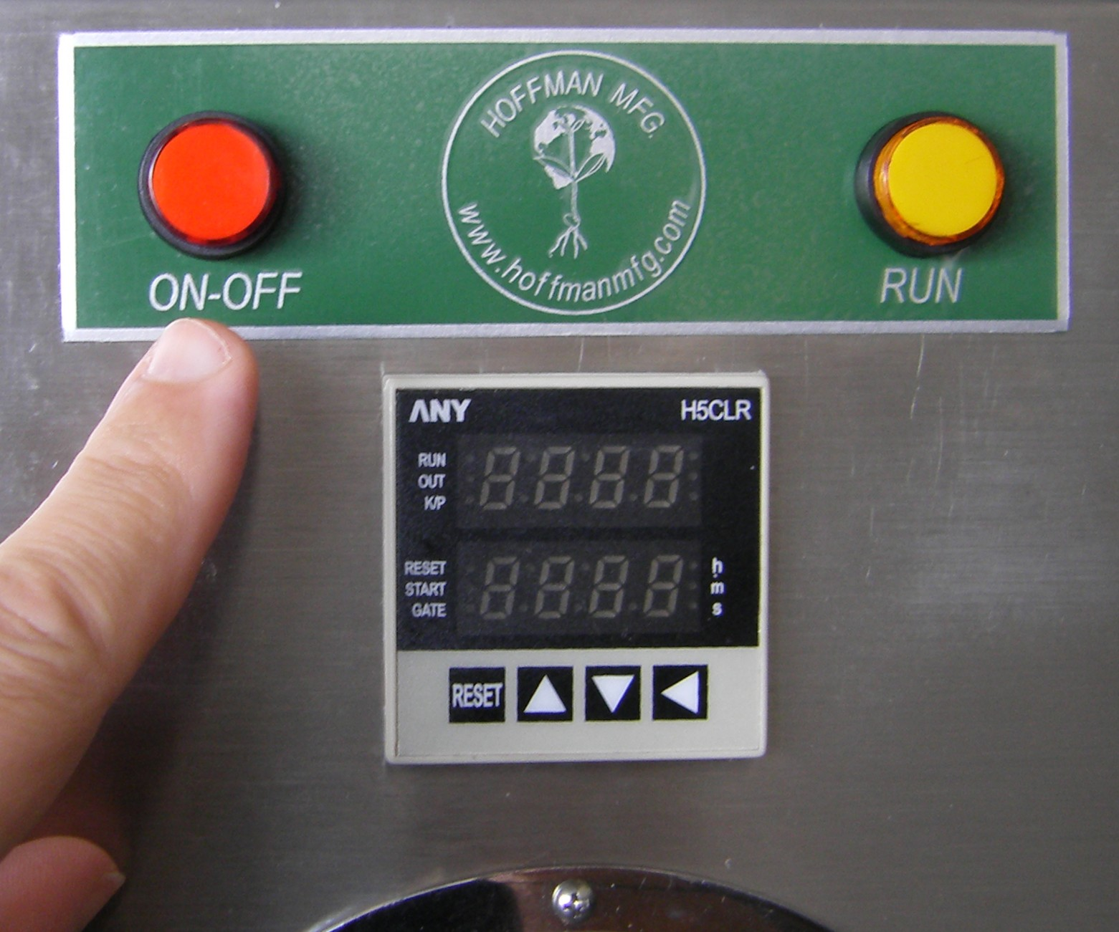
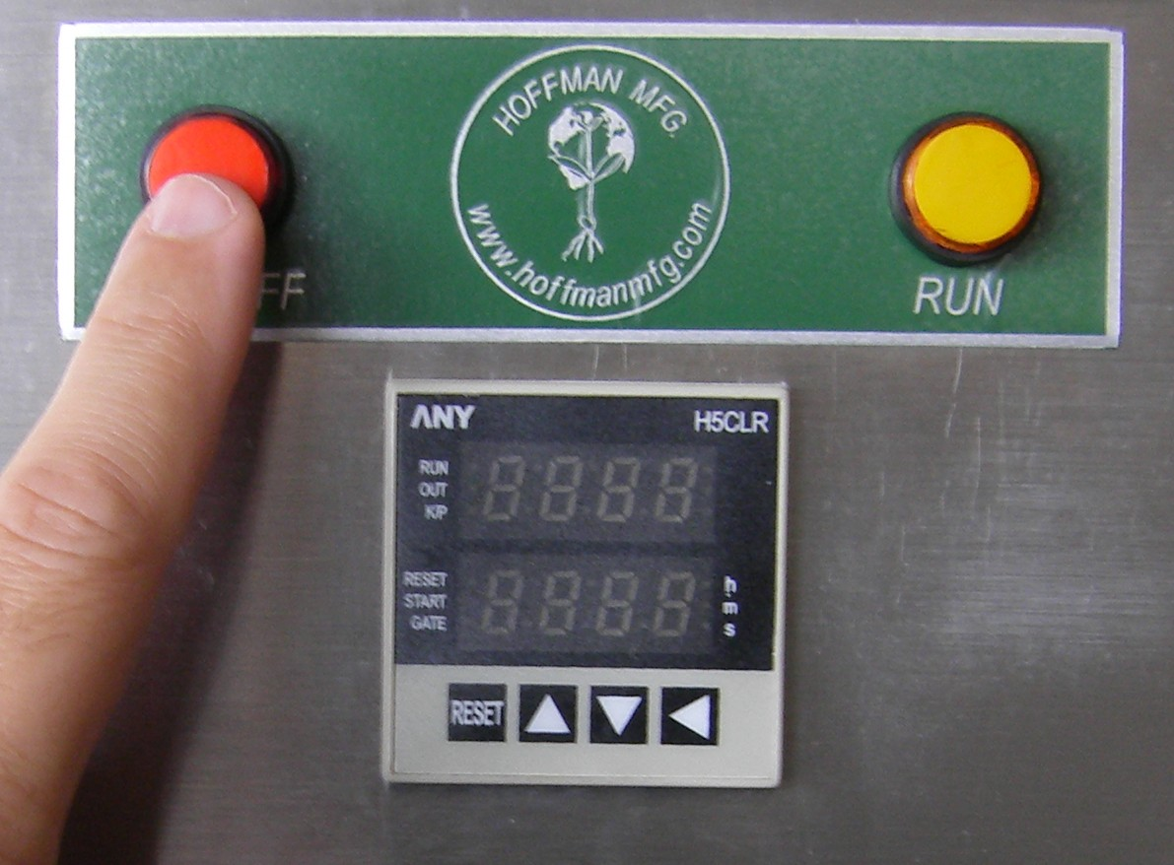
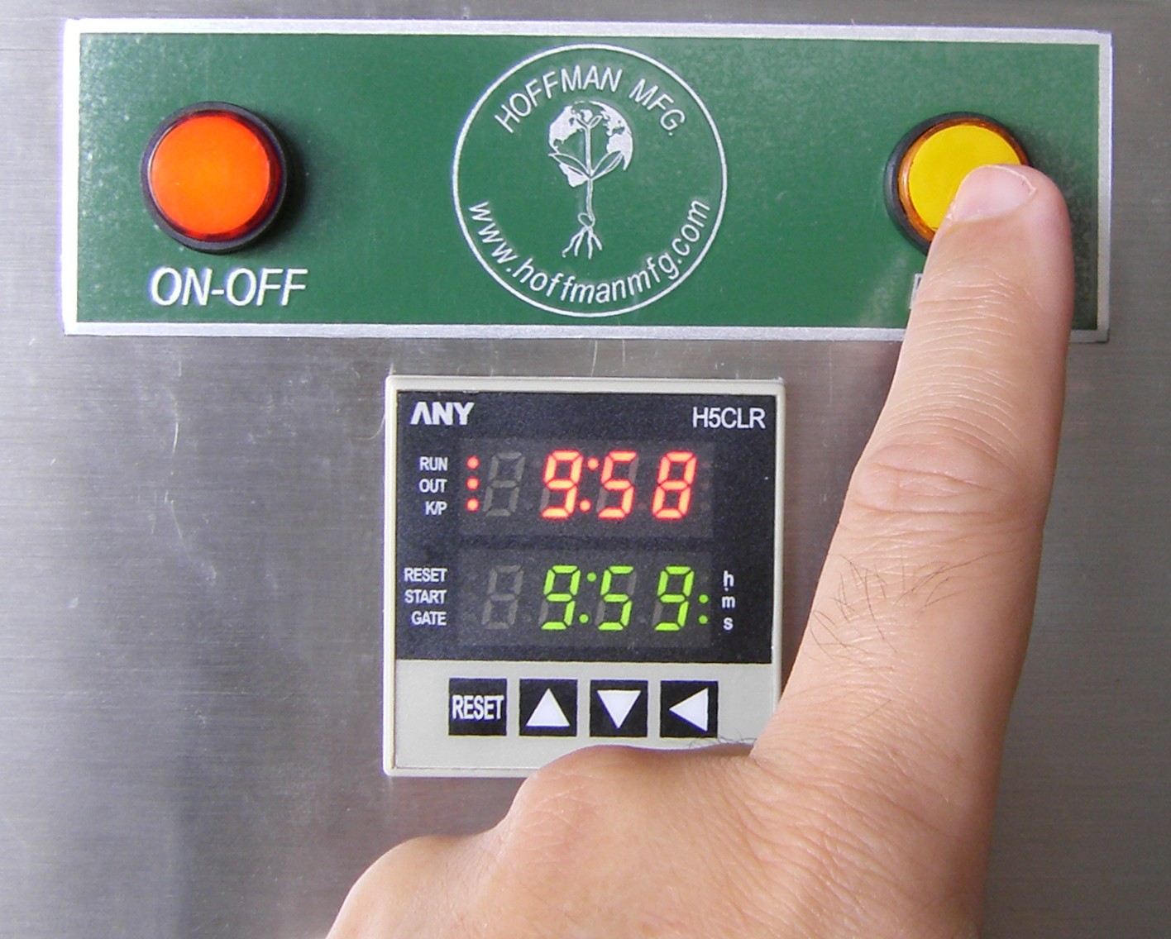
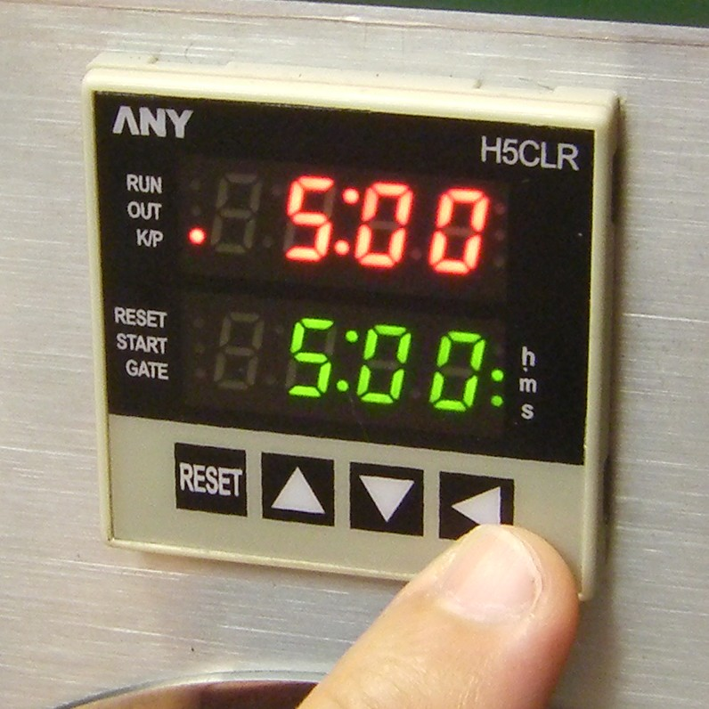
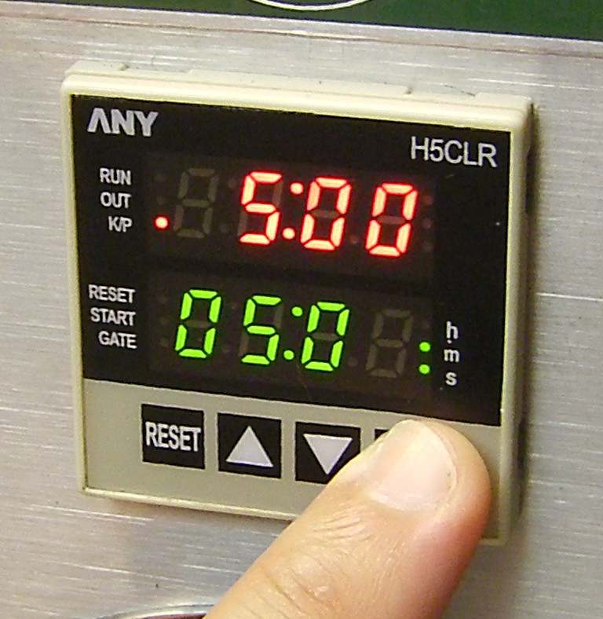
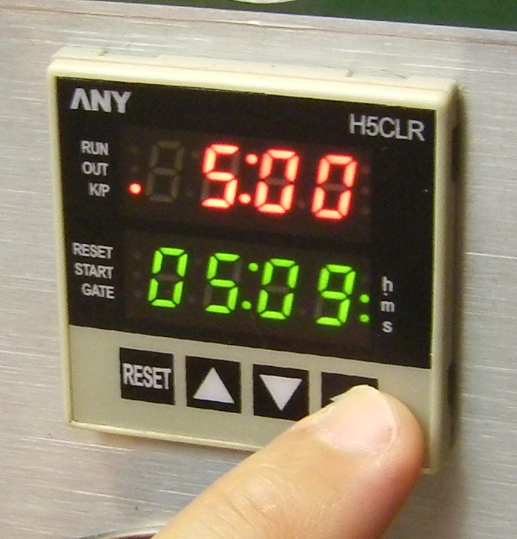
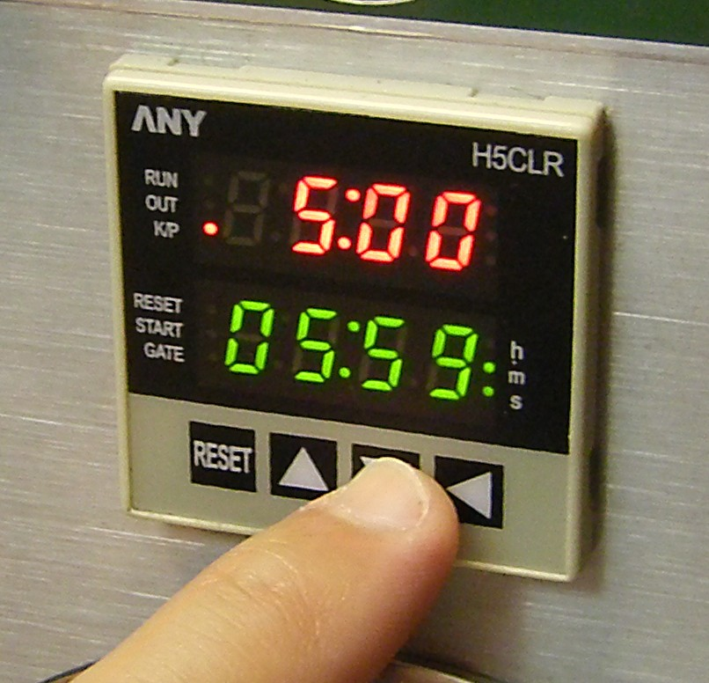
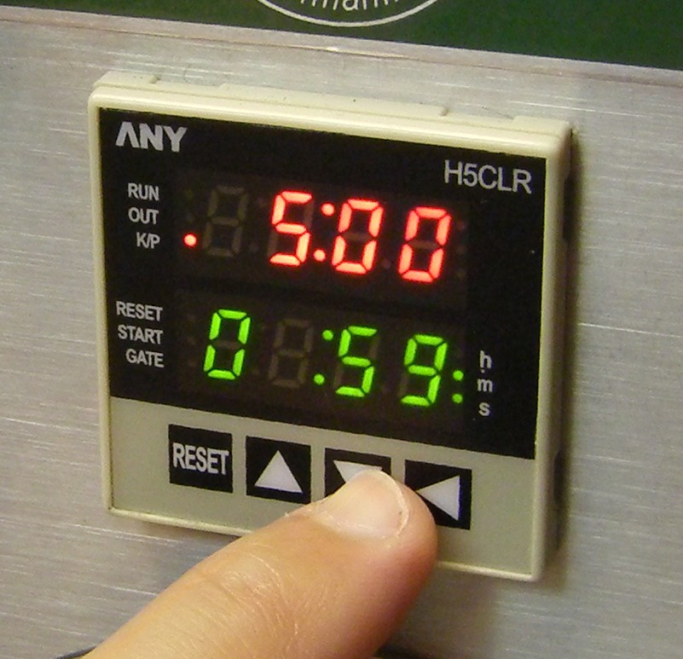
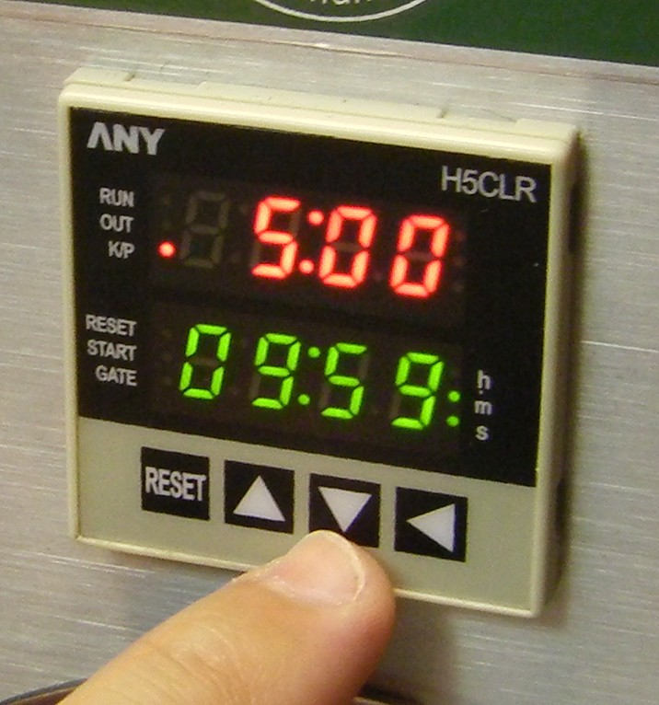
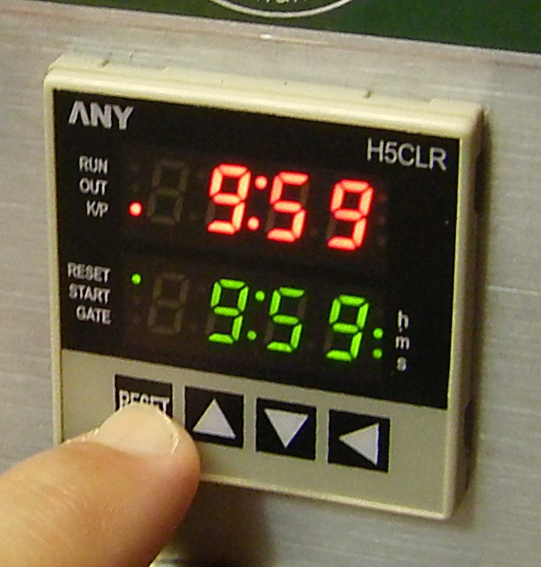
1. Turn the equipment on by pressing - the ON-OFF Red Push Button -
3. To change the target time, press the ◄ KEY (LEFT ARROW) as shown. The display will blink. Then press the ▼ KEY (DOWN ARROW) or the ▲ KEY (UP ARROW), as many times as needed, to scroll the value of the first digit (seconds). Press the ◄ KEY again to shift to the next digit position (if needed) to scroll the value of the second digit (seconds). Repeat the same procedure to find the digits to set the minutes by pressing the ◄ KEY again to shift to the next digit position. After 5 seconds without any setting activity, this function will be deactivated itself without saving the changes.

All information above is subject to change without prior notice
HOW TO SET THE DIGITAL TIMER
2. The Red Push Button will illuminate as well as the timer. The Timer will display the last test run time (red digits), and the last target time (green digits). Both times in minutes and seconds (mm:ss). (See note A)
5. Press the Amber Push Button (as shown) to run the test. The timer will countdown immediately.
4. Press the RST KEY to save the new desired target time.
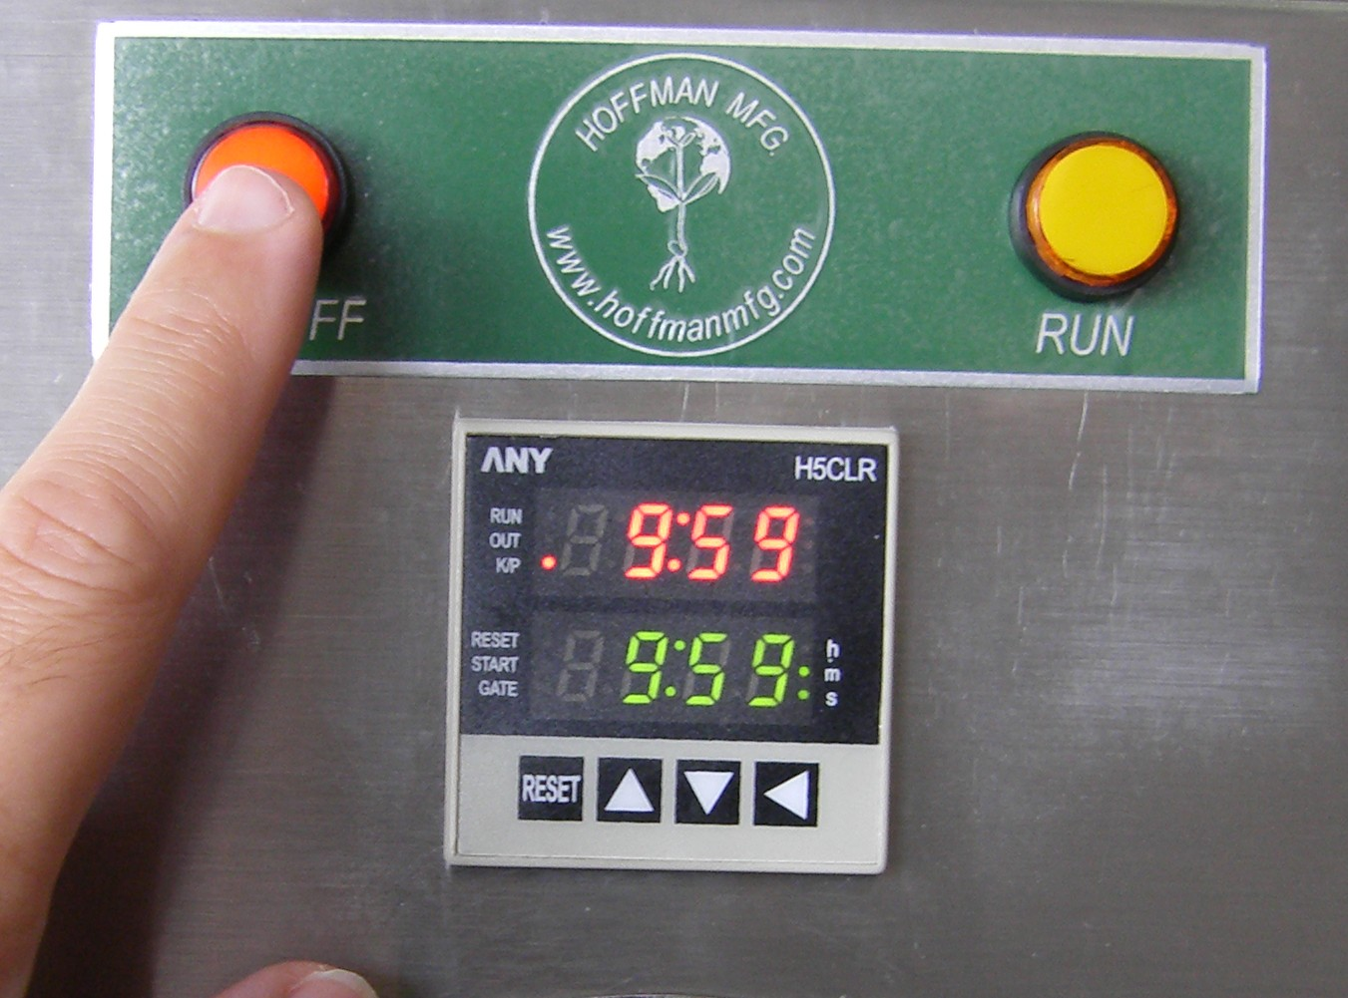
Note A:

Notice that the timer will show the values of the last setting or performed test, if there is no need to set a new target time, go to step 5 directly, otherwise go to step 3.

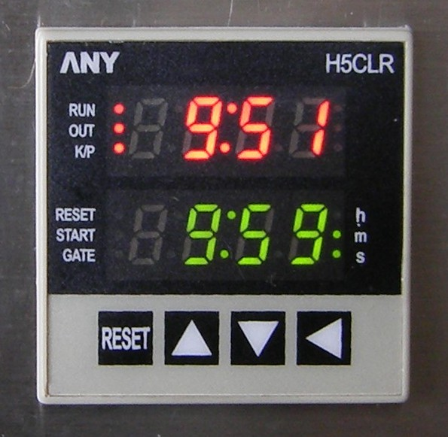
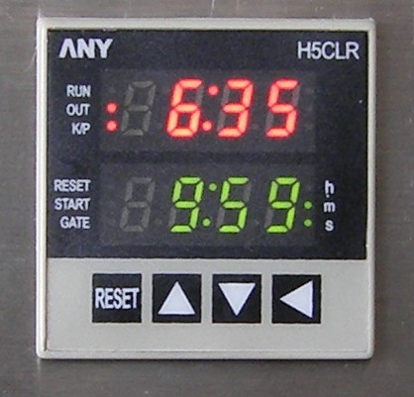
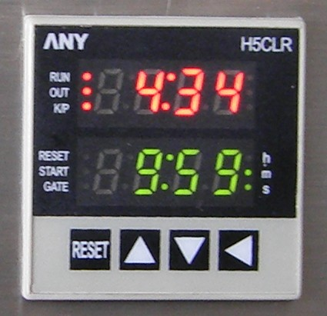
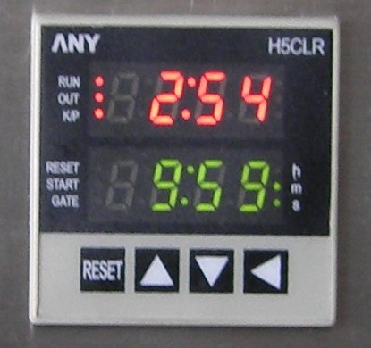

6. While the test is in progress, the timer is counting down the time as shown on the pictures. The Equipment will stop running after completing the required target time. The digital timer will reset to the last target time automatically.

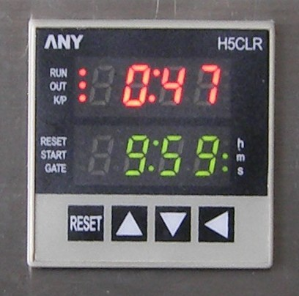

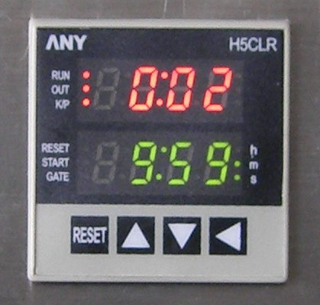
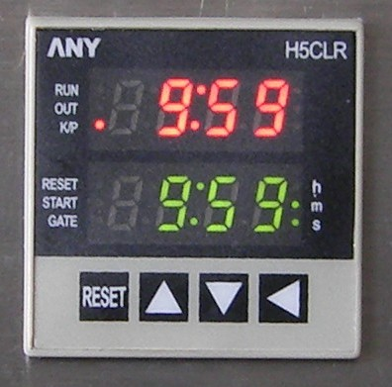

7. The digital timer will reset to the last target time automatically.

Note B:
If you need to interrupt the test, while is in progress, by pressing the RST KEY, will stop the fan and reset the timer to the target time

immediately.
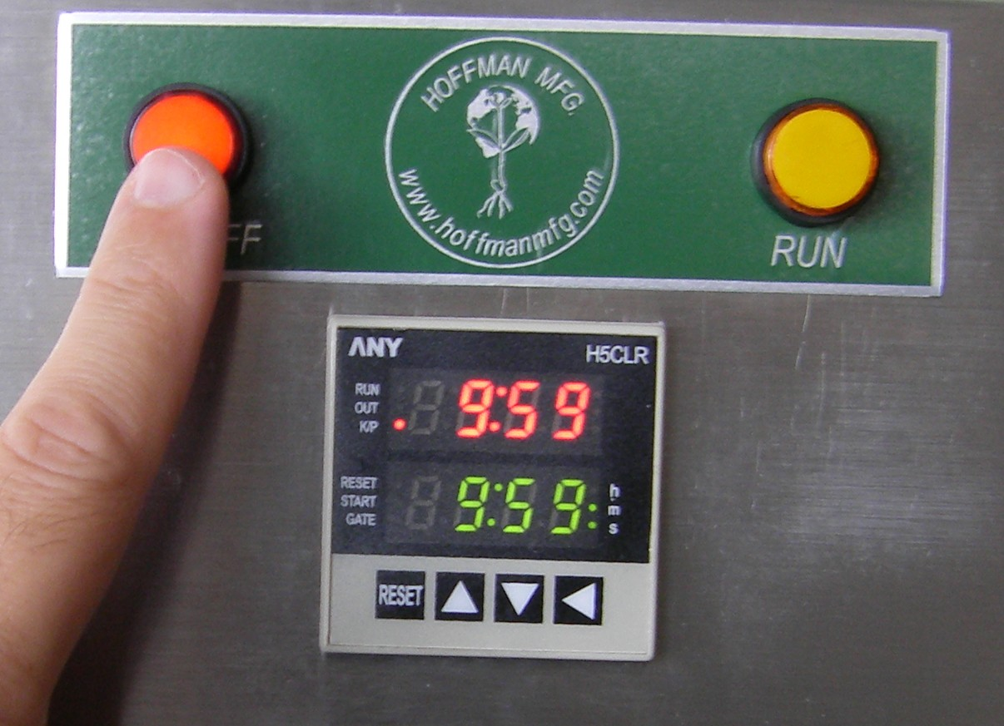
8. To turn the Seed Blower OFF, press the Red Push Button. This Button is also used to STOP the equipment in case of an emergency. Also Read Note B.

Note C:
Always keep the Seed Blower’s Red Push Button in OFF position (no illumination) when loading or unloading the equipment.
If you are not sure, disconnect the equipment from the power source.
If you are not going to use the Seed Blower for a long period of time, unplug it from the power source.
Follow your local electric code regulations
by consulting an electrician.

